**SMART STAR EXAMINATIONS BOARD**

**END OF TERM ONE EXAMINATION - 2024**

**SOCIAL DEVELOPMENT**

**TOP CLASS**

My name is…………………………………………

1. **Read and draw.**

tree

star

fish

sun

moon

1. **Match the names to pictures.**

church

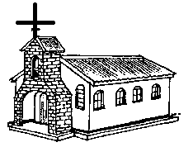

garden

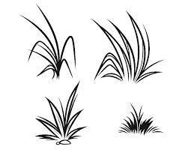

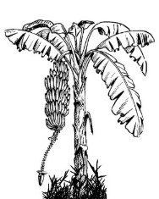Mosque 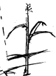

1. 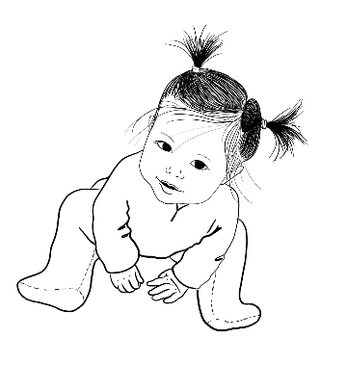**Tick the correct word.**

brother baby goat

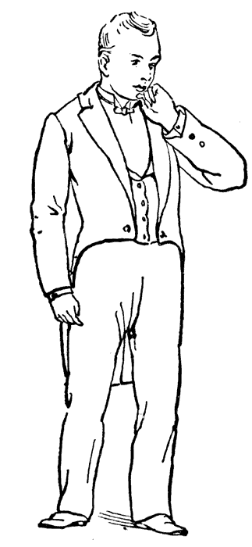

fan sister father

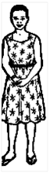

father cat mother



sister bell sick

1. **Fill in the missing letter.**

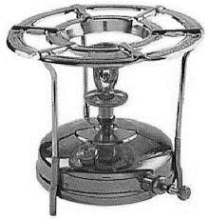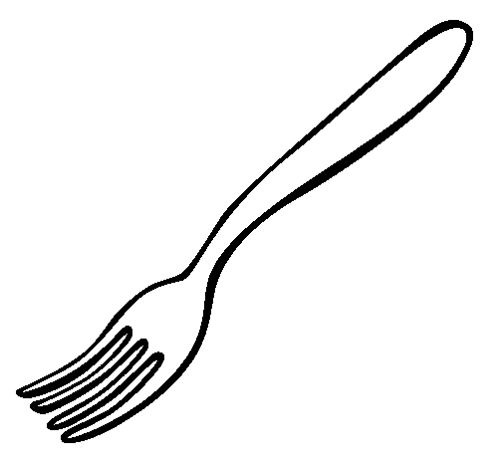f__rk s__ove

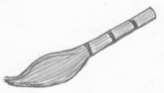

br_ _m 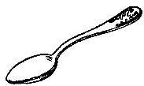__ poon

1. **Oral work.**

i) Why do you come to school?

ii) What is the name of your father?

iii) What is the colour of your

uniform?

iv) Tell the things we use to keep

the environment clean.

1_____________ 2 _____________

v) Where do you go when you

are sick?

1. **Circle the things we use to keep the environment clean.**

toilet bed chair toilet

pen dustbin dustbin

tree rack spoon rack

1. 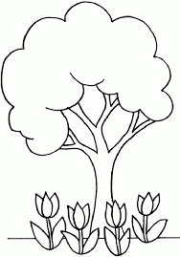**Colour a home.**

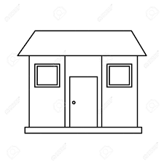

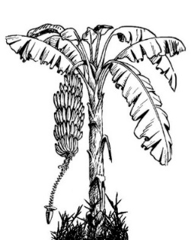

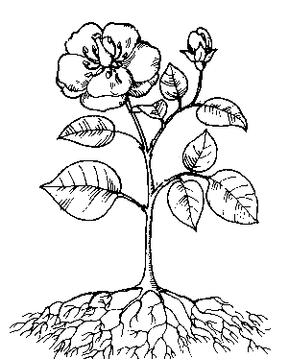

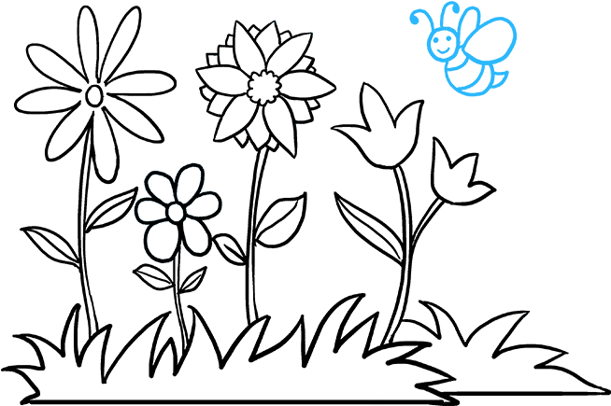

1. **Underline the correct word.**

hospital mosque shop

toilet tree hospital

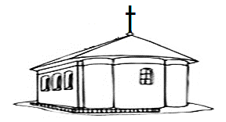

market church school.

**END**